DESIGN AND SIMULATION OF AN 8-BIT ALU

Objective:
To design and verify a 8-bit Arithmetic Logic Unit (ALU) implementing basic arithmetic and logical operations using Verilog HDL.

Software used:
Visual Studio Code, Icarus Verilog and GTKWave.

Methodology:
Combinational | Sequential
Output only depends on the present input. | Output depends on the present input and past output.
Memory element is absent. | Memory element is present.
No clock signal is applied. | Clock signal is required.
Combinational | Memory  Combinational
Example: Half adder, Full adder, Multiplexer | Example: Flipflops, Counters, Registers
The ALU was modeled using combinational logic in Verilog. A testbench was developed to check the functionality of the main code. Functional verification was performed using iVerilog and GTKWave.

Operations:
Opcode | Operation
000 | A + B (Addition)
001 | A - B (Subtraction)
010 | A & B (AND)
011 | A | B (OR)
100 | A^B (XOR)
101 | ~A (NOT)
110 | A<<1 (Logical left Shift)
111 | A>>1(Logical Right Shift)

Verilog Code:
module alu (
input [7:0] A,
input [7:0] B,
input [2:0] opcode,
output reg [7:0] result,
output reg carry,
output reg zero
);
always @(*) begin
carry = 0;
case (opcode)
3'b000: {carry, result} = A + B; // ADD
3'b001: {carry, result} = A - B; // SUB
3'b010: result = A & B; // AND
3'b011: result = A | B; // OR
3'b100: result = A ^ B; // XOR
3'b101: result = ~A; // NOT
3'b110: result = A << 1; // LSHIFT
3'b111: result = A >> 1; // RSHIFT
default: result = 8'b0;
endcase
zero = (result == 0);
end
endmodule

Test bench:
module alu_tb;
reg [7:0] A, B;
reg [2:0] opcode;
wire [7:0] result;
wire carry, zero;

alu uut (
.A(A),
.B(B),
.opcode(opcode),
.result(result),
.carry(carry),
.zero(zero)
);

initial begin
$dumpfile("alu.vcd");
$dumpvars(0, alu_tb);

A = 8'd10; B = 8'd5;
opcode = 3'b000; #10; // ADD
opcode = 3'b001; #10; // SUB
opcode = 3'b010; #10; // AND
opcode = 3'b011; #10; // OR
opcode = 3'b100; #10; // XOR
opcode = 3'b101; #10; // NOT
opcode = 3'b110; #10; // LSHIFT
opcode = 3'b111; #10; // RSHIFT
$finish;
end
endmodule

Expected outcome:
Opcode | Operation | A | B | Expected Result (R)
000 | A + B | 10 | 5 | 15
001 | A - B | 10 | 5 | 5
010 | A & B | 10 | 5 | 0
011 | A | B | 10 | 5 | 15
100 | A^B | 10 | 5 | 15
101 | ~A | 10 | - | 5
110 | A<<1 | 10 | - | 20
111 | A>>1 | 10 | - | 5

Calculations:
In decimal, A = 8’d10; B = 8’d5
In binary, A = 4’b1010; B = 4’b0101
In hexadecimal, A = 0xA; B= 0x5

Addition:
In decimal, A + B = 10 + 5 = 8’d15
In hexadecimal, A + B = 0xA + 0x5 = 0xF

Subtraction:
In decimal, A - B = 10 + 5 = 8’d5
In hexadecimal, A - B = 0xA + 0x5 = 0x5

AND operation:
In binary,
A = 1010
B = 0101
R = 0000
In hexadecimal, R = 0x0

OR operation:
In binary,
A = 1010
B = 0101
R = 1111
In hexadecimal, R = 0xF

XOR operation:
In binary,
A = 1010
B = 0101
R = 1111
In hexadecimal, R = 0xF

NOT operation:
In binary,
A = 1010
~A = R = 0101
In hexadecimal, R = 0x5
Left Shift by 1-bit:
In binary,
A = 0000 1010
R = 0001 0100
In hexadecimal, R = 0x14

Right Shift by 1-bit:
In binary,
A = 0000 1010
R = 0000 0101
In hexadecimal, R = 0x5

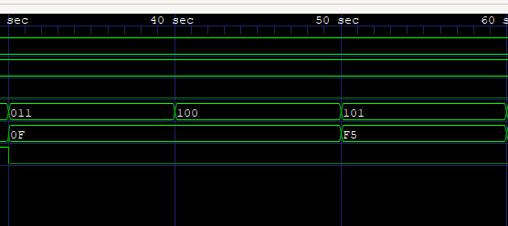
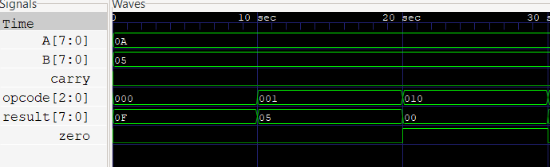
Results:
